Docker Challenge

- Create a customized Docker image using a Dockerfile.
First lets create a directory and add a custom webpage that we can copy in our docker file
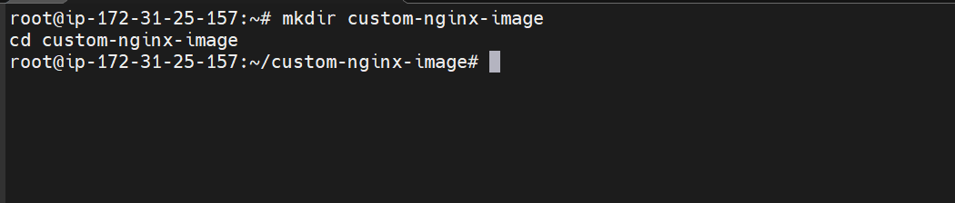
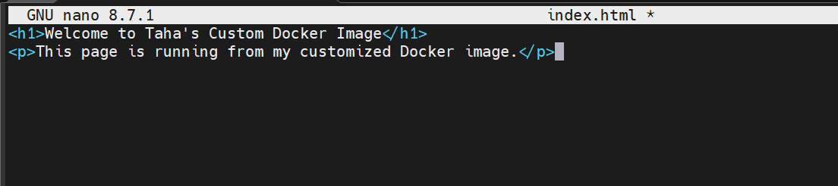

Lets create a docker file
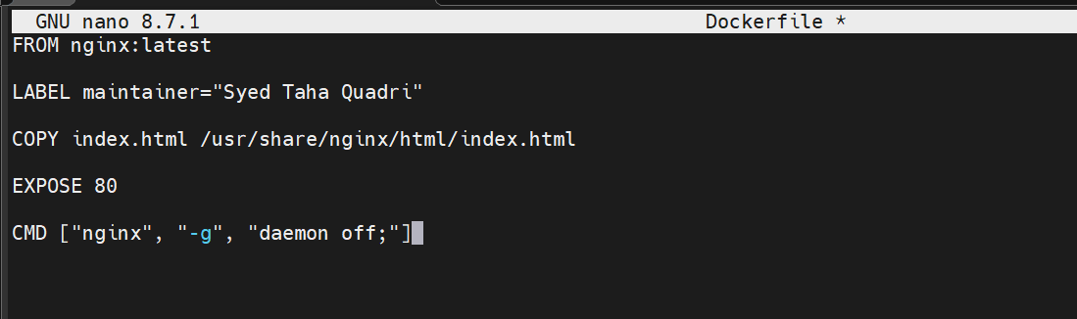

This is our docker file which for nginx
Lets build this file now
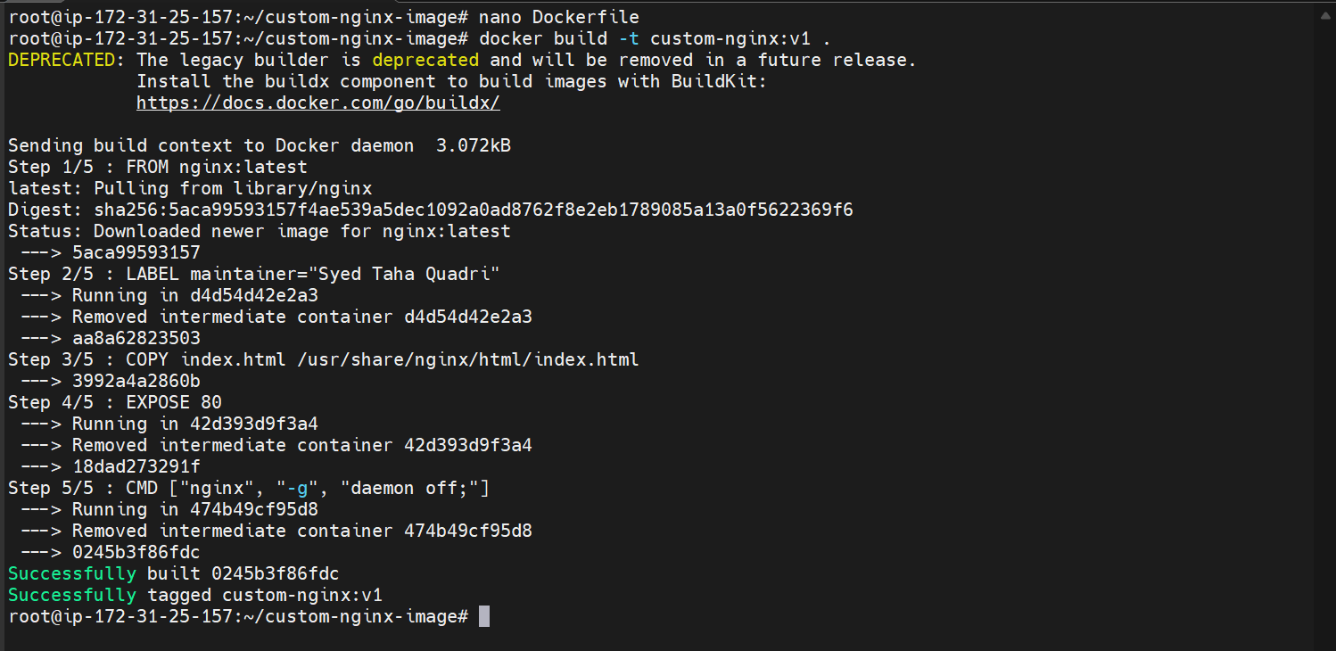
The docker file is now built
Lets now run the container
The container is up and running now
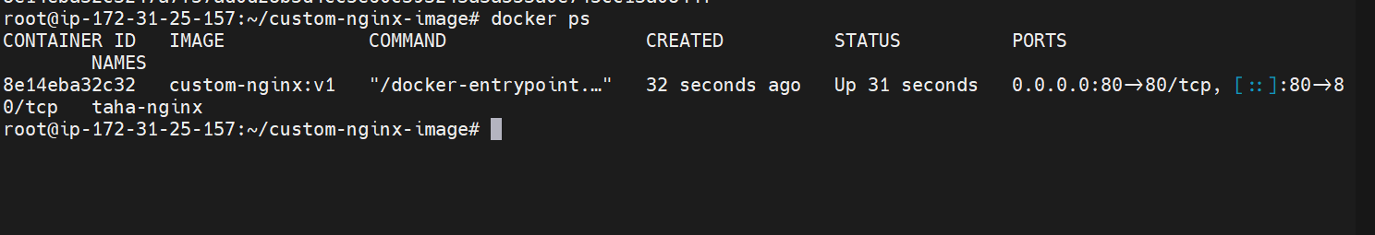
Lets check it now on browser

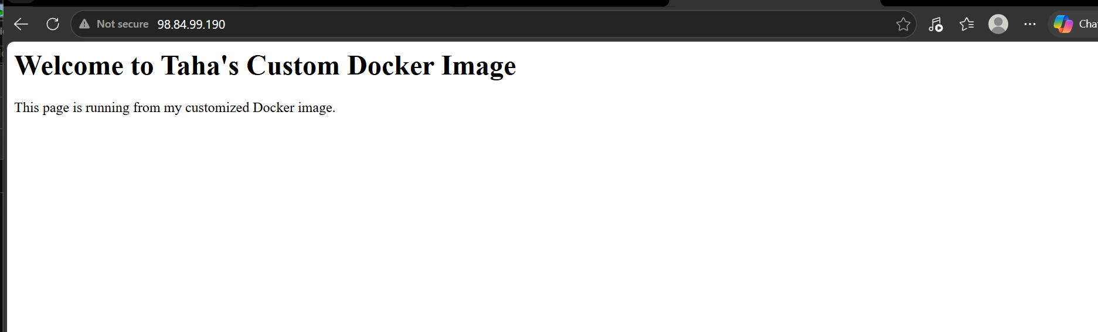
We can see the web page on browser as well.

- Push the image to Docker Hub.

Lets push image the custom image to docker hub

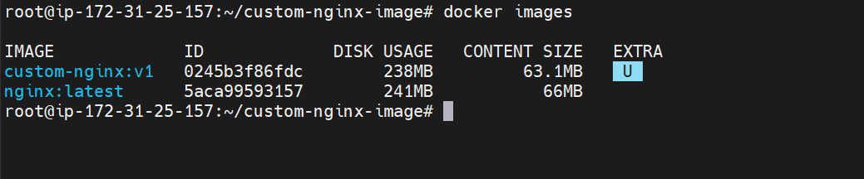

Lets login to docker hub using docker cli

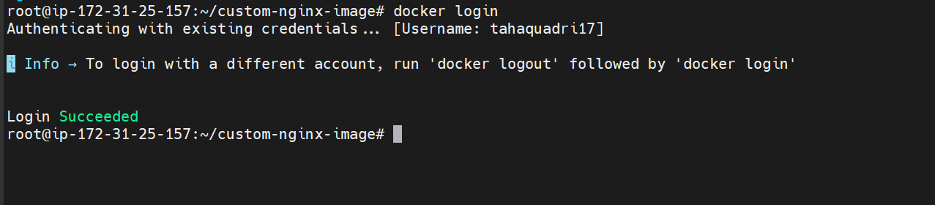

Lets now tag the image according to docker hub username

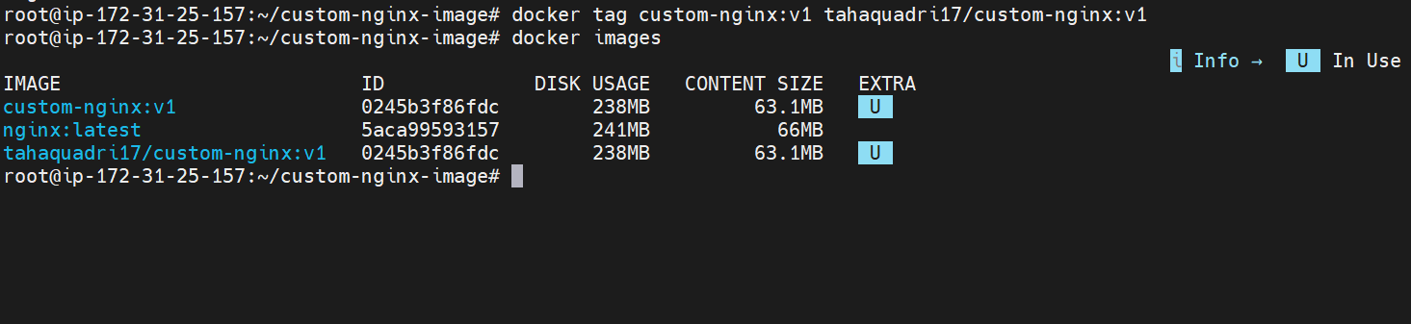

Finally lets push to docker hub

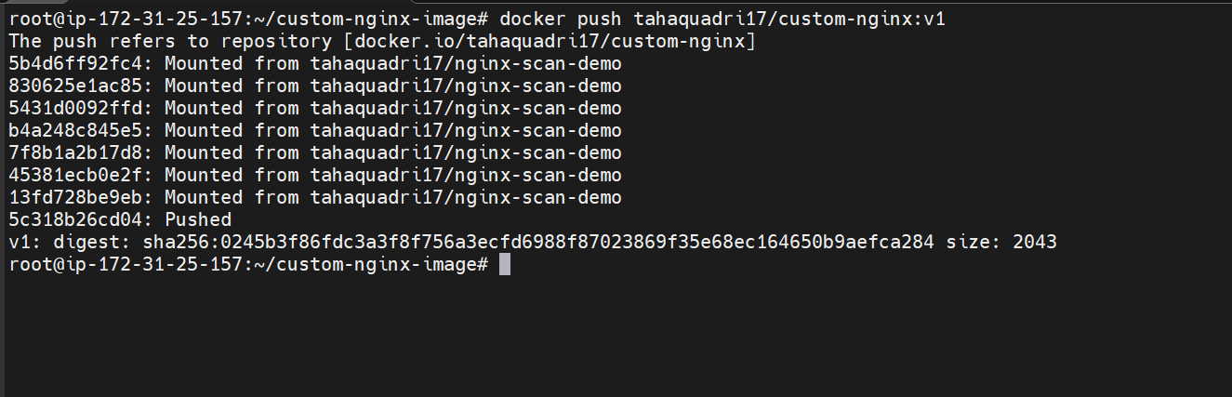

The image has been pushed to docker hub

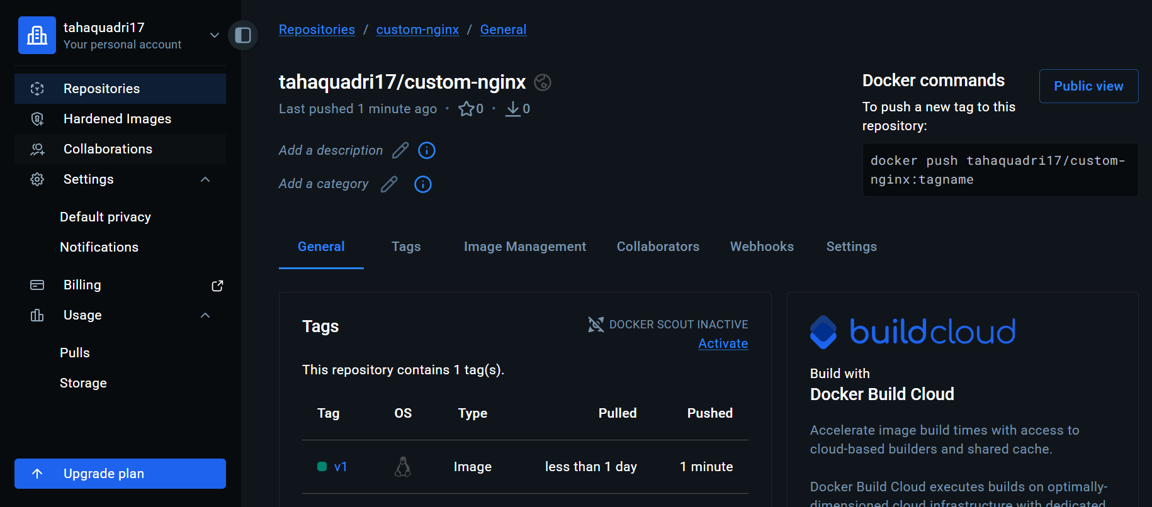

- Push the same image to Amazon ECR.

First lets create a repo in AWS ECR

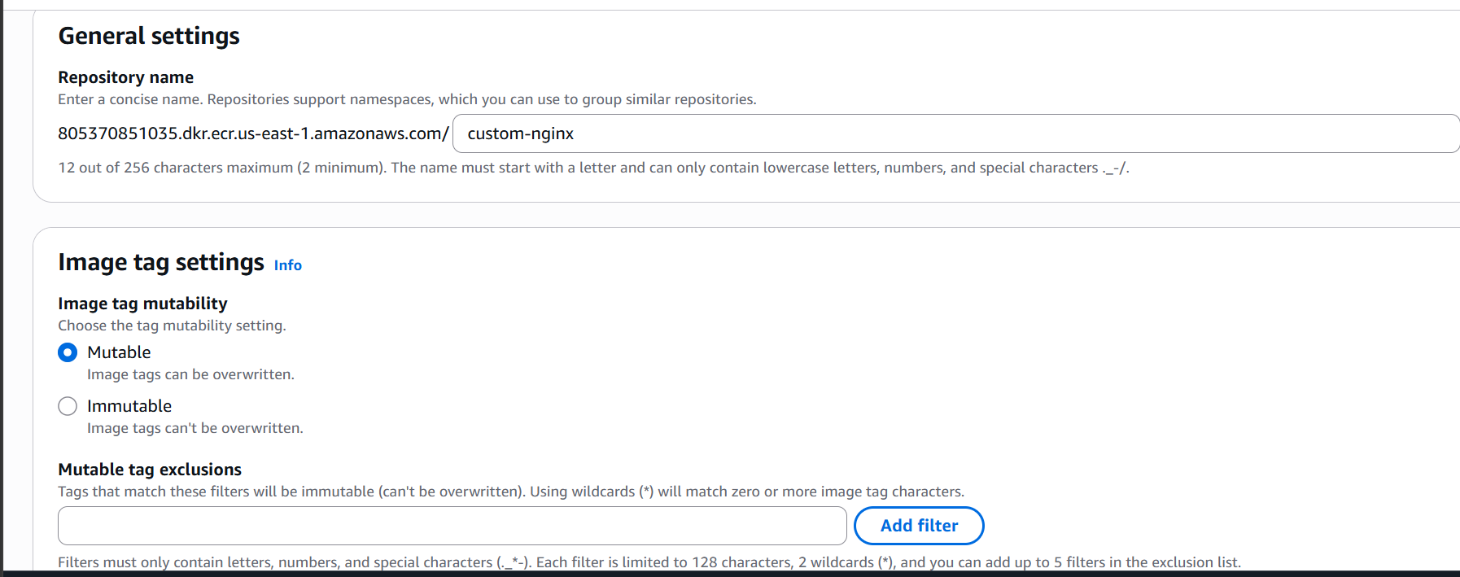

Now lets login to ECR for this we should have aws cli installed and credentials must me configured

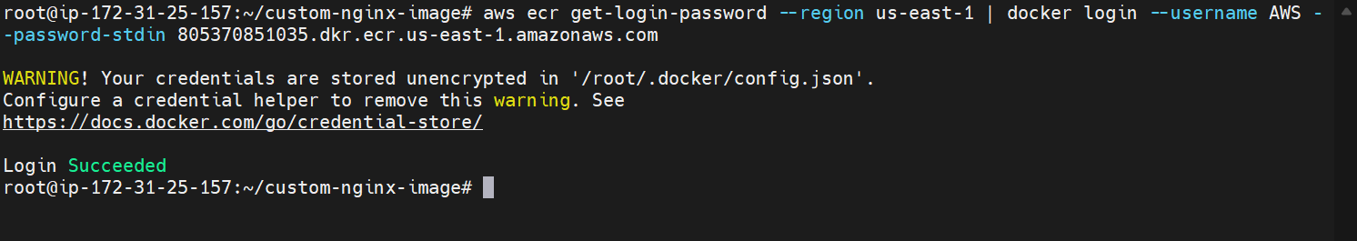
Tagging the image now according to ECR

The image is now pushed to ECR

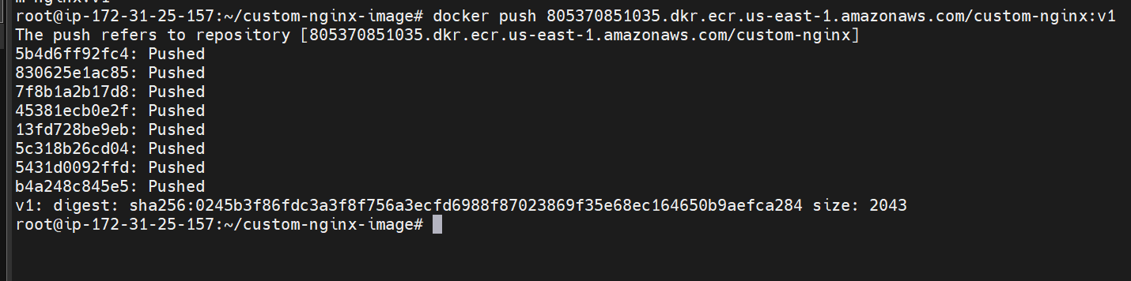

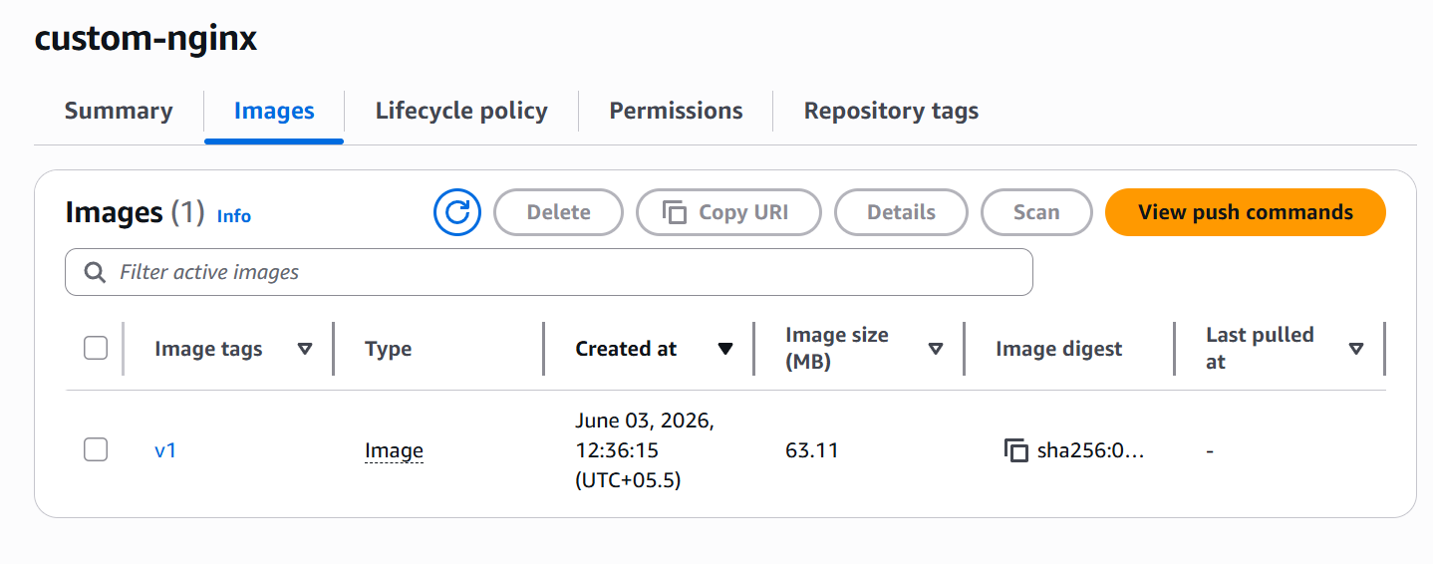

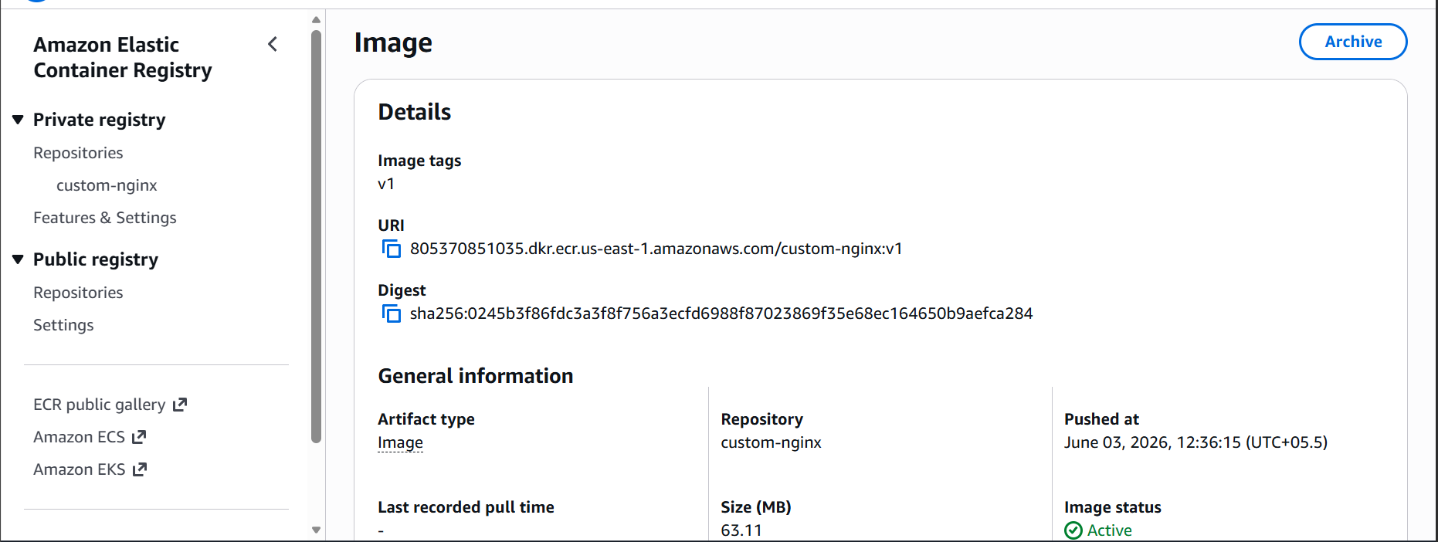

- Provision one EC2 instance using Terraform and install Jenkins.

Aws cli configure

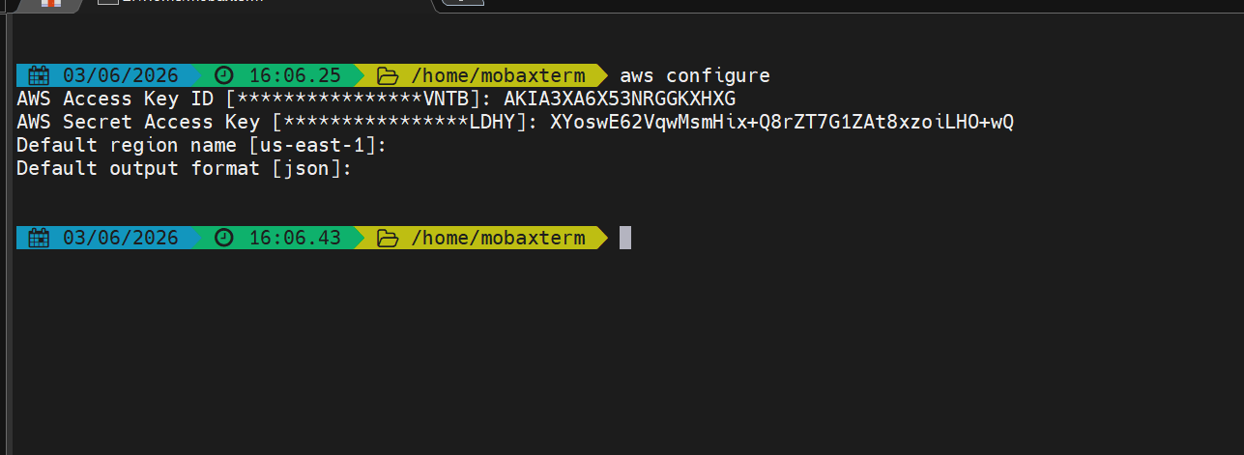

Now lets create a project directory
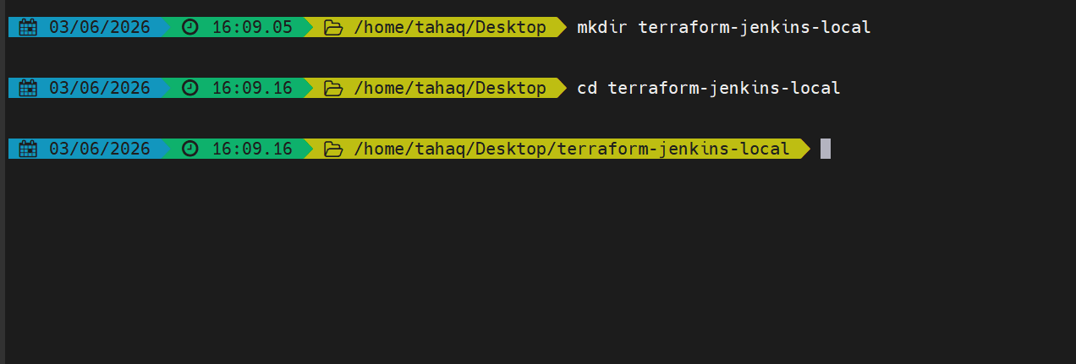

Lets now write our terraform code
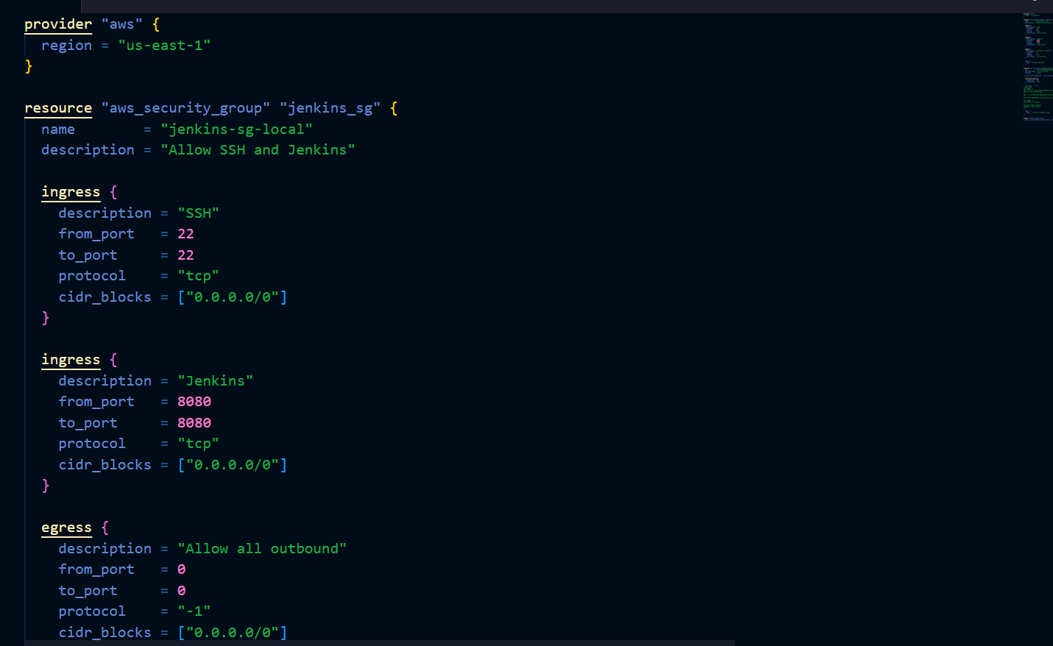

Here we are creating a security group
Allowing ssh and 8080 for Jenkins server and also we are allowing outbound to anywhere

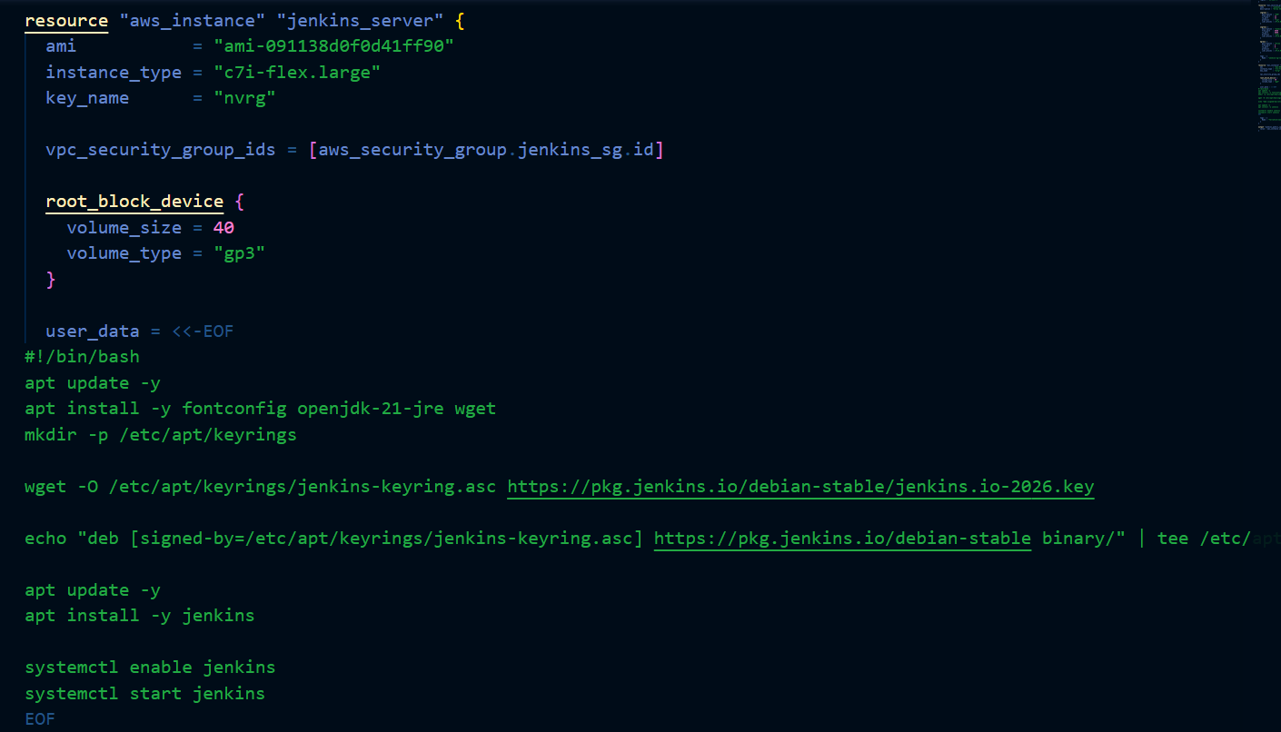

Here we are creating the ec2 instance with 40gb volume size and also we are installing Jenkins inside it using the user data option

Lets now provision the instance

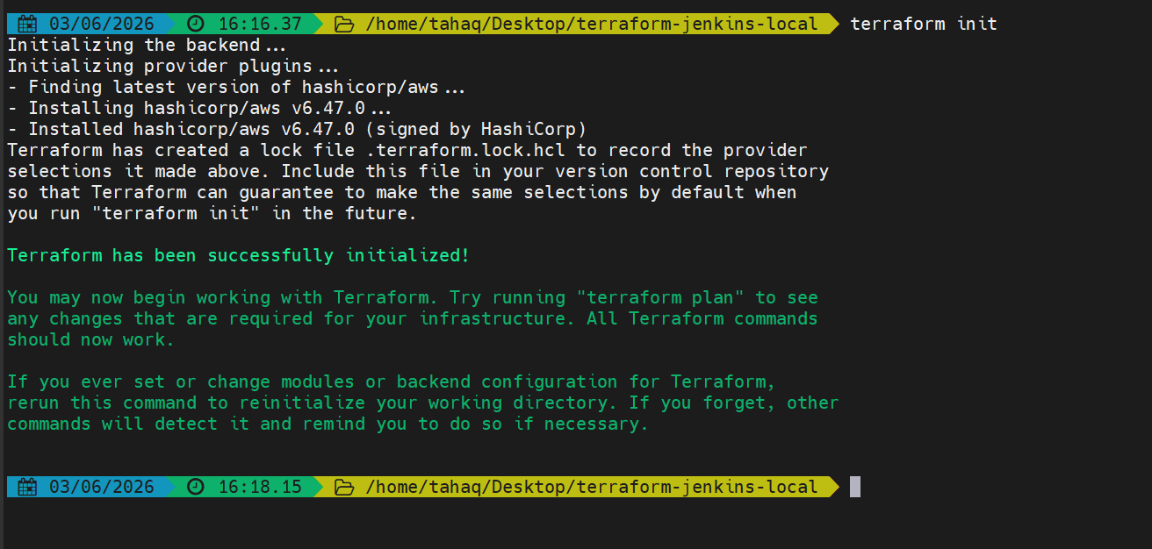

Terraform validate
This will check for any syntactical errors

Terraform plan
This will show us what is going to change after appyling
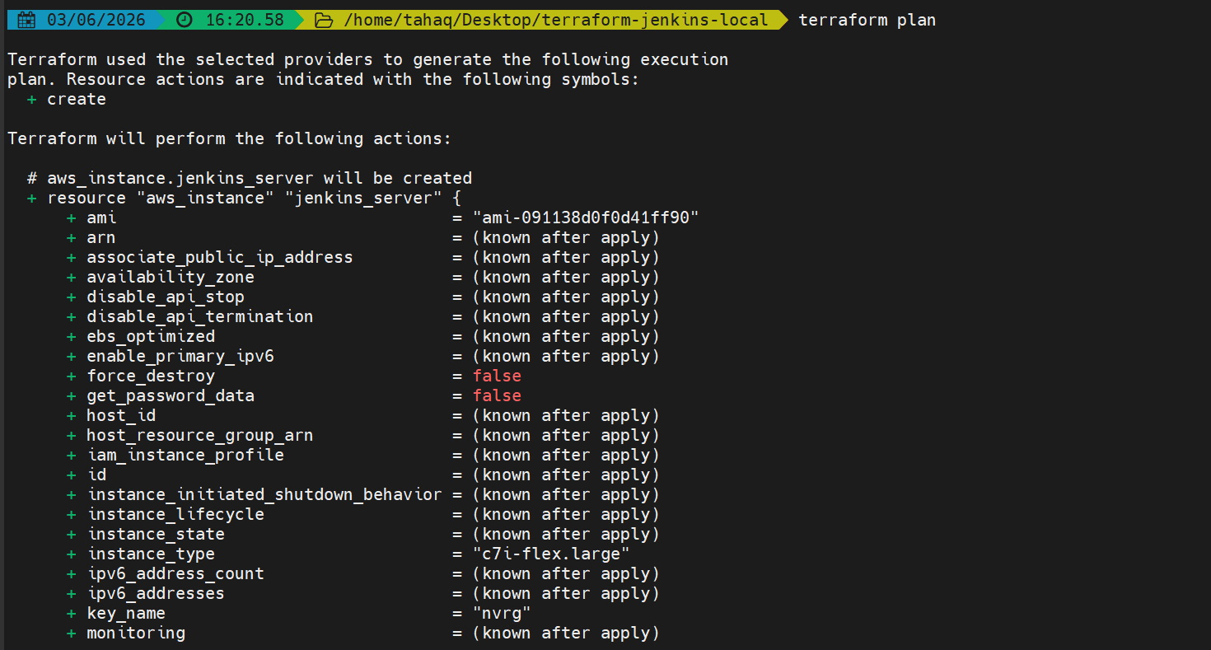

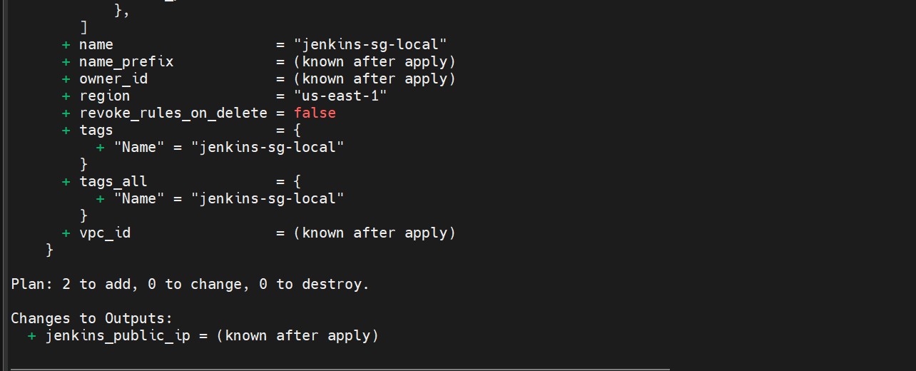

Here we can see that there are two things to add i.e security group and instance

Terraform apply
This will create the infra we want

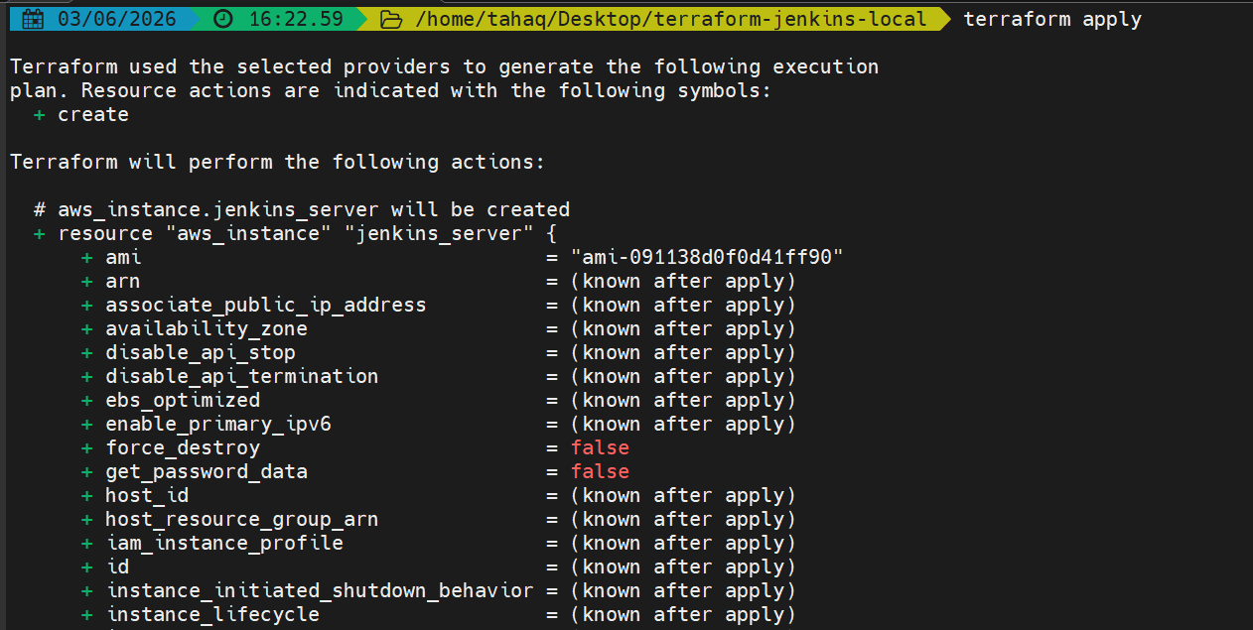

It will ask for approval once we say yes the provisioning will happen
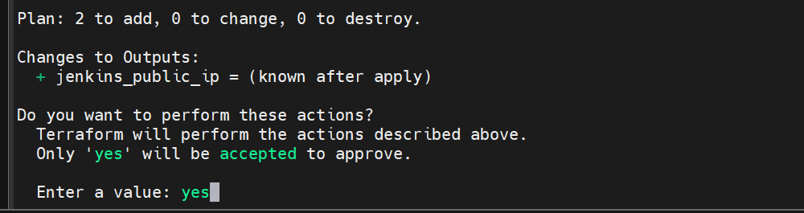

Provisioning is done
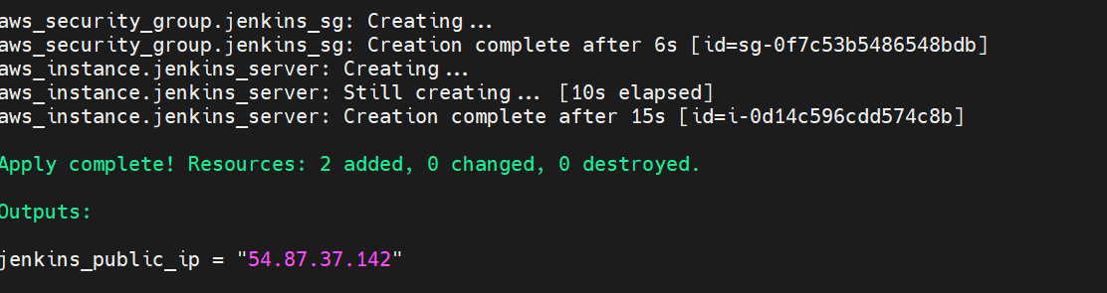

Lets validate in our aws console

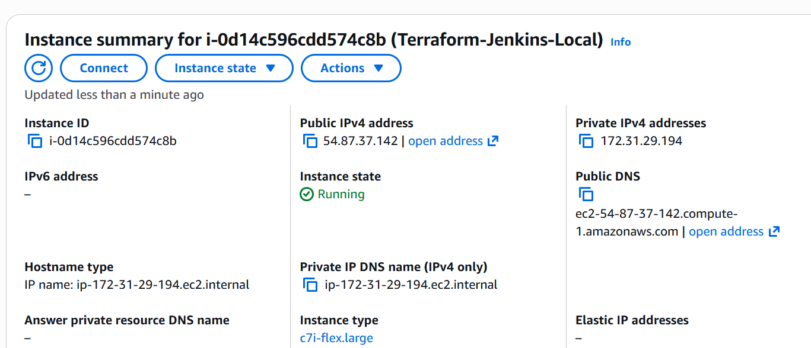

We can see the instance is created
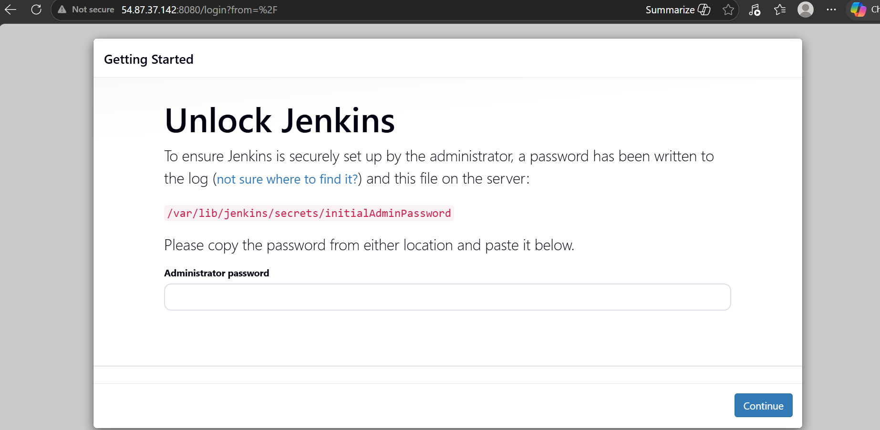

Jenkins is also accessible on 8080

Lets ssh into server and get the password to login to Jenkins server
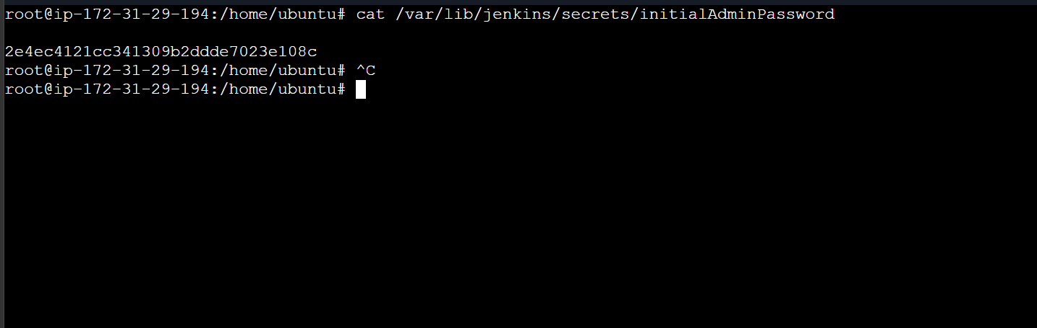
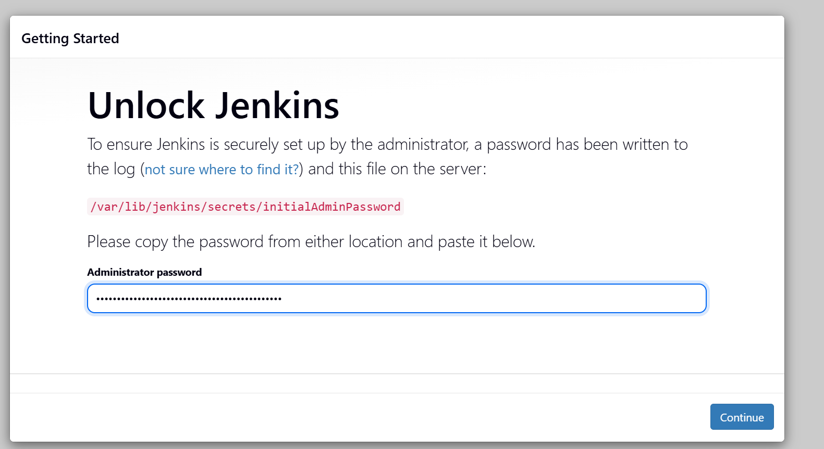

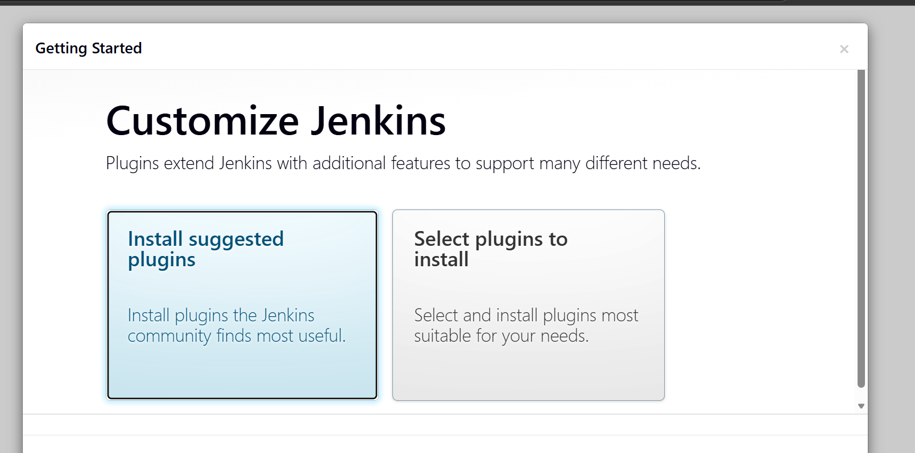

We are now logged in to Jenkins server
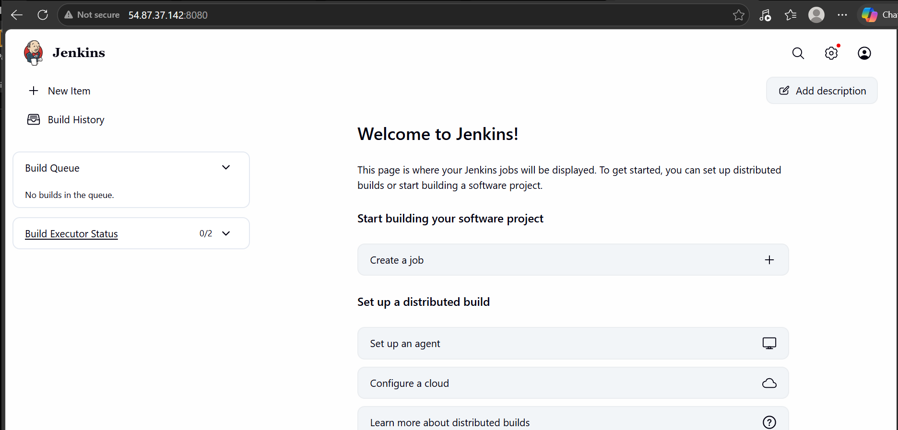

- Create one Jenkins job to build and push the Docker image to Docker Hub.
Source:https://github.com/betawins/Python-app.git

First lets add docker hub credentials in Jenkins server

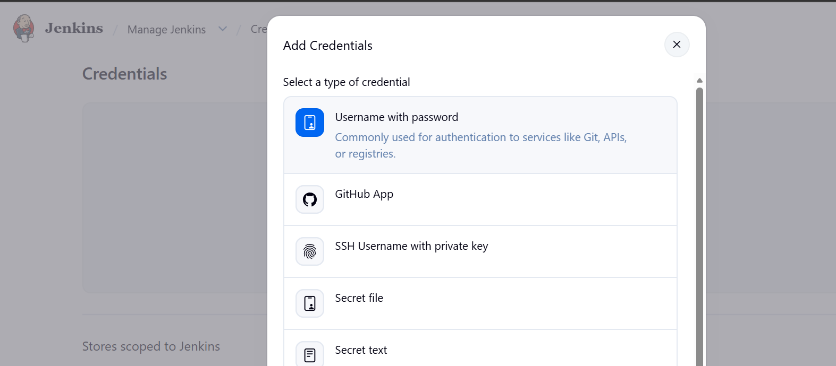
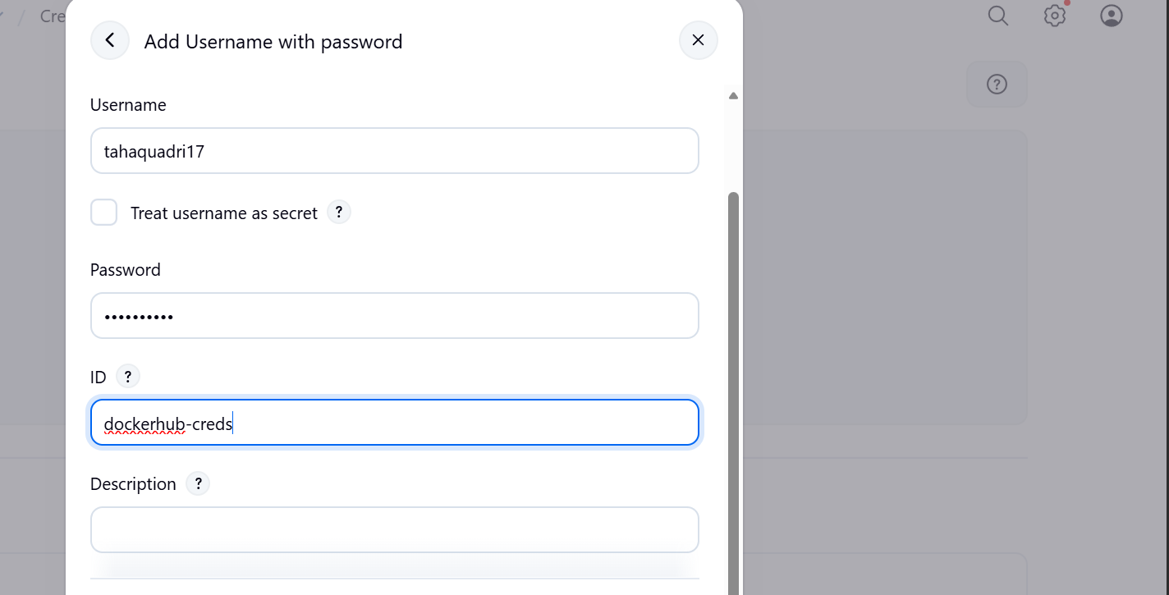

Now install the docker pipeline plugin

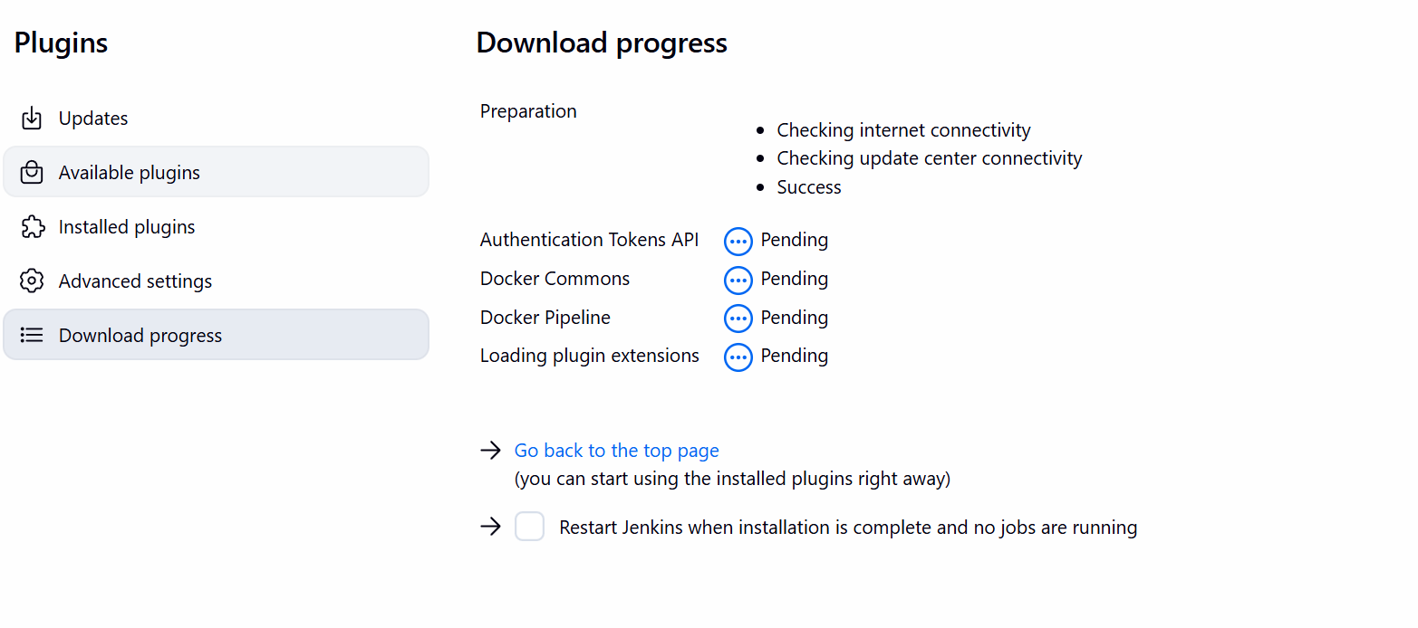

Creating a pipeline
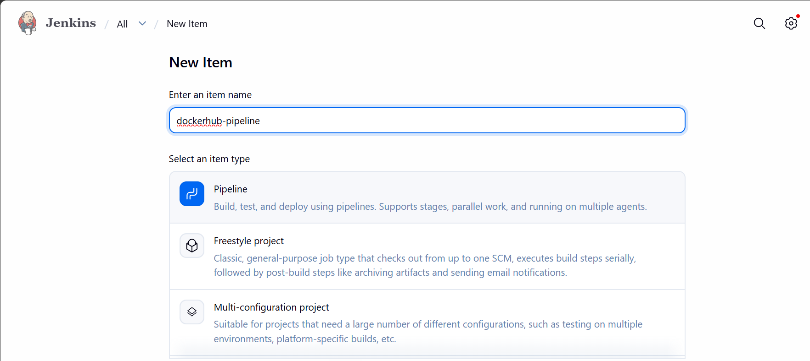

Write the pipeline script

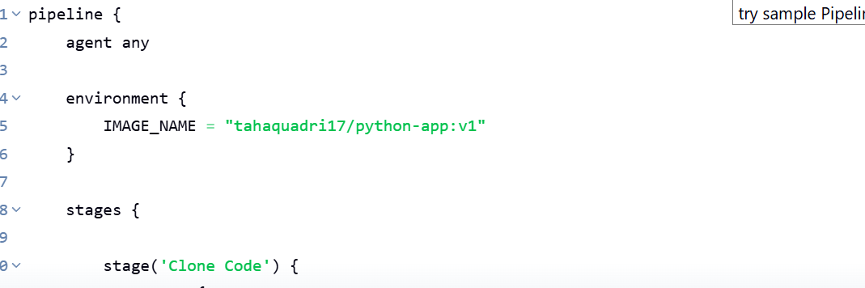

Git clone

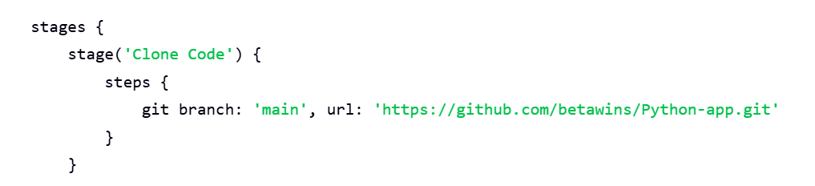

Building the docker image
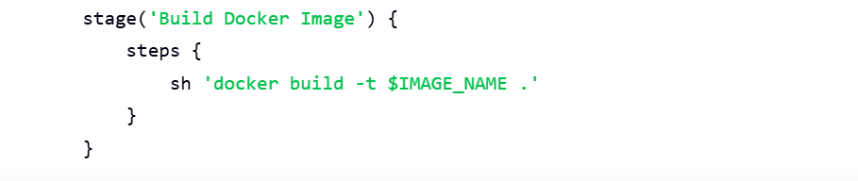

Pushing the image to docker hub using the credentials

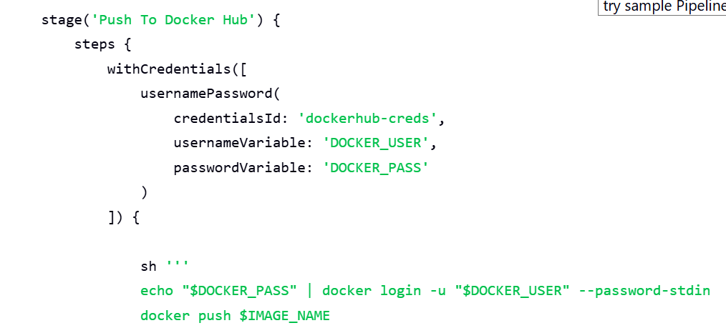

Lets run the pipeline now

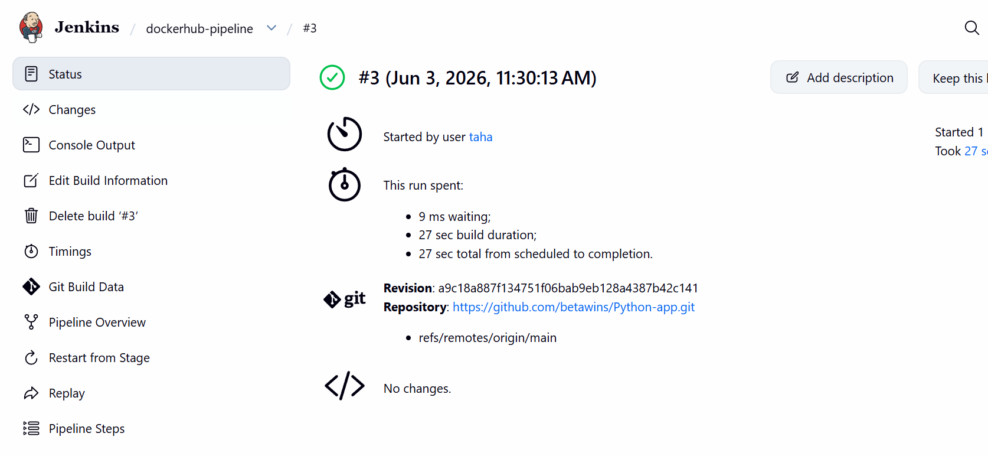

The pipeline ran successfully
Lets confirm it in dockerhub
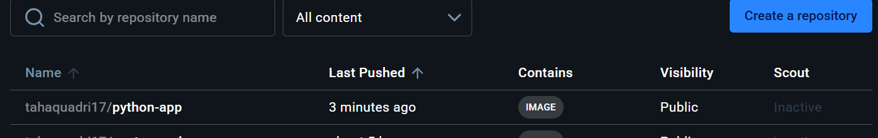

The image is successfully pushed to docker hub

From thefrontend source code, write a Dockerfile, build a Docker image, run it, and push that image to your Docker registry.

First lets clone the repository

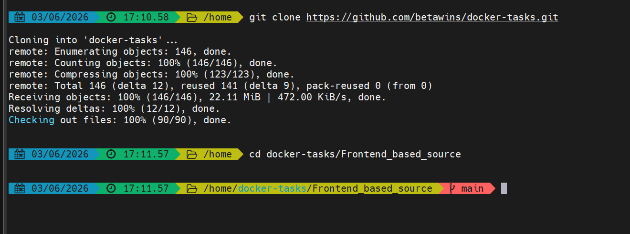

Lets now write a docker file

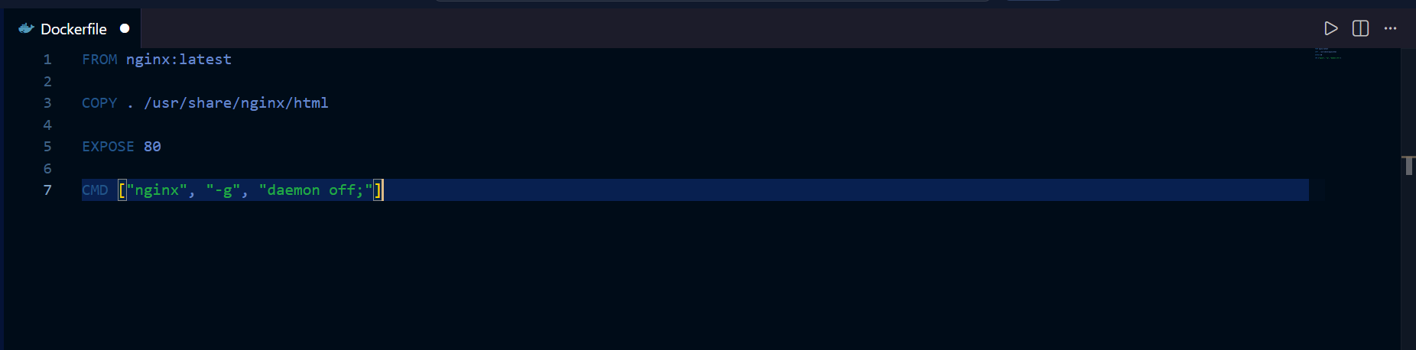

This docker file downloads the latest nginx image and copies all the files from current directory to /usr/share/nginx/html

Lets now build the image
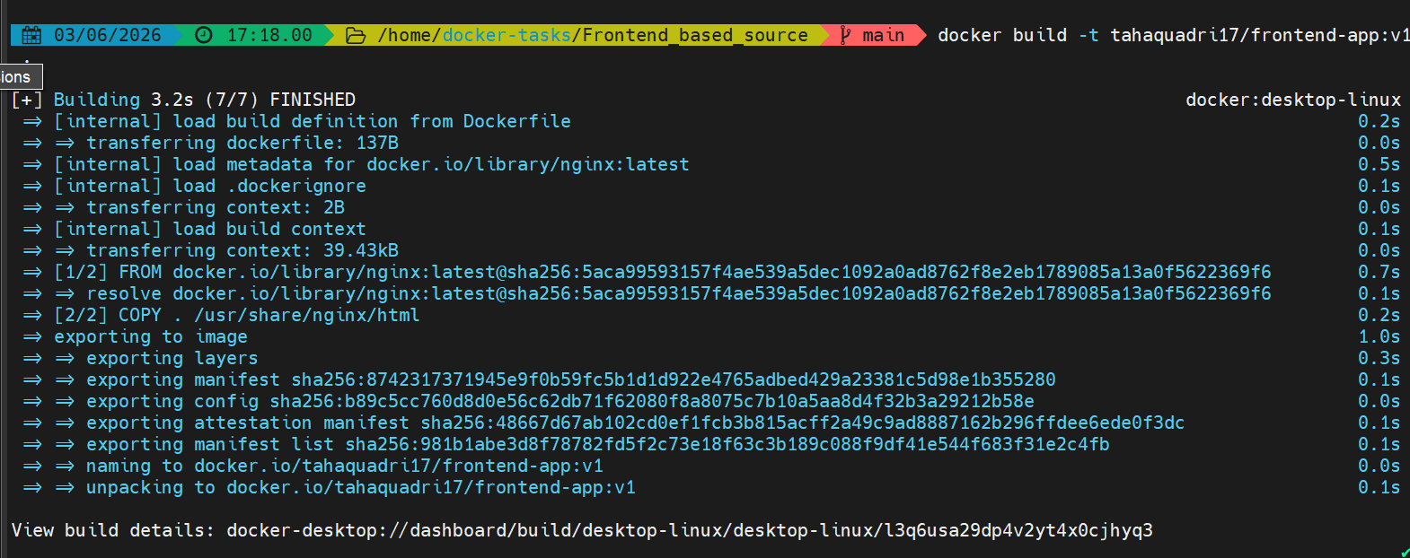

The image is built

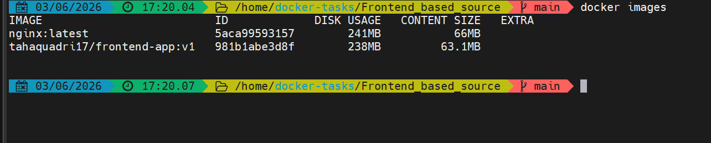

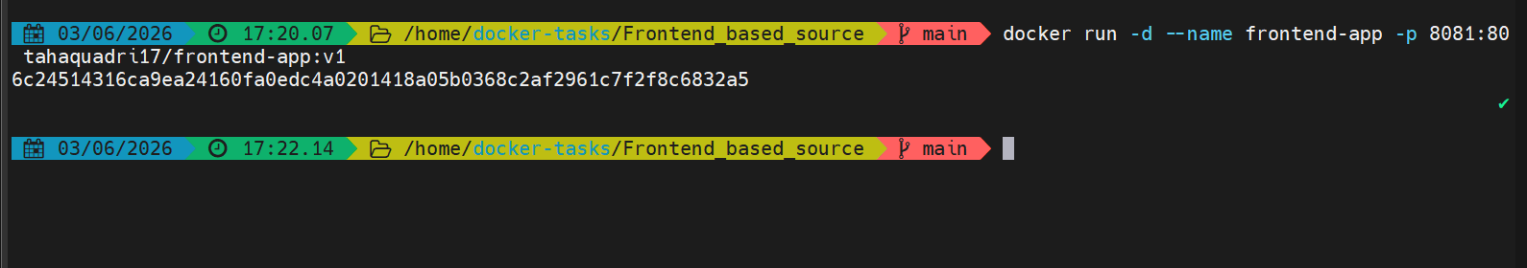

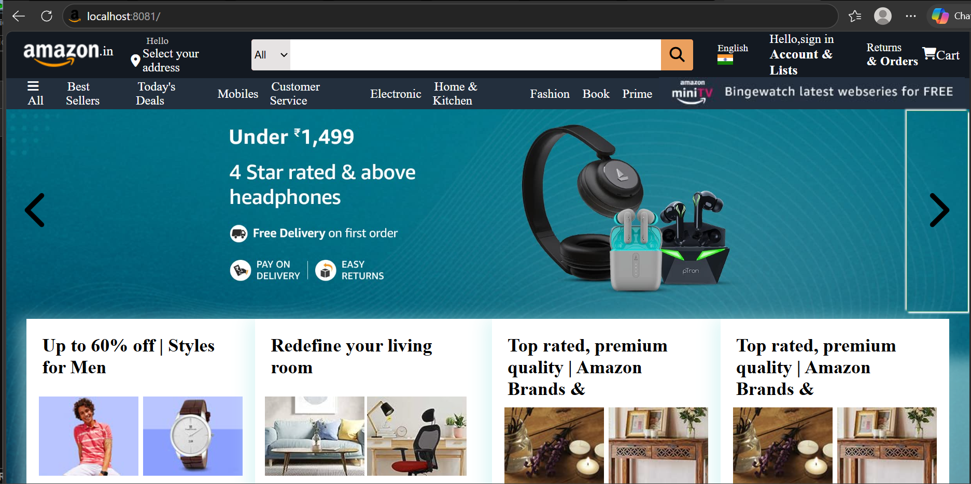

The webpage is accessible on port 8081
The image is pushed to dockerhub as well
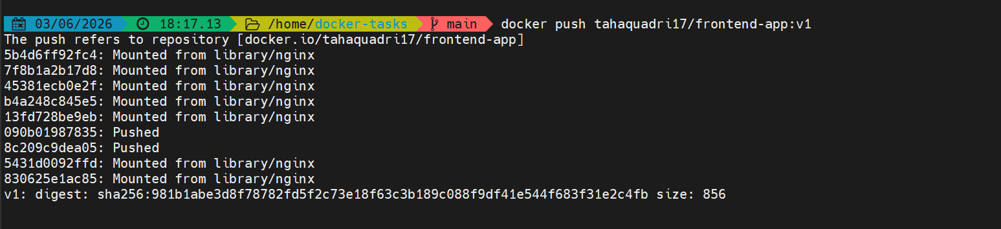
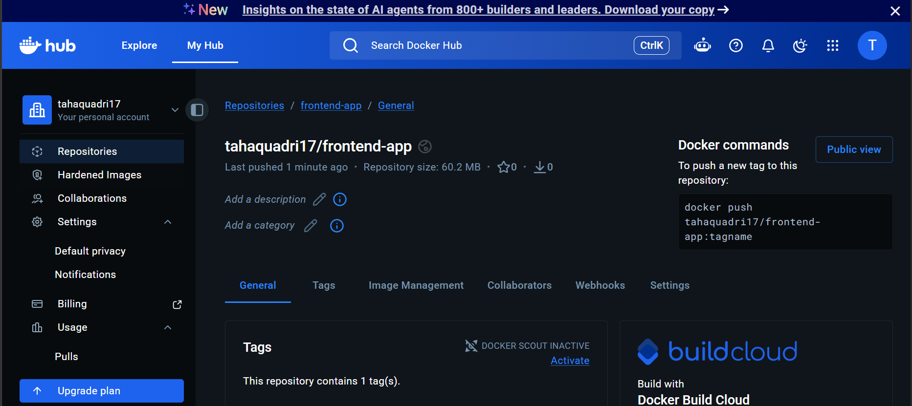

From the Java-based source code, write a Dockerfile, build, run, and push the image to the Docker registry
Now lets do it for the java based code
Go to java based code directory
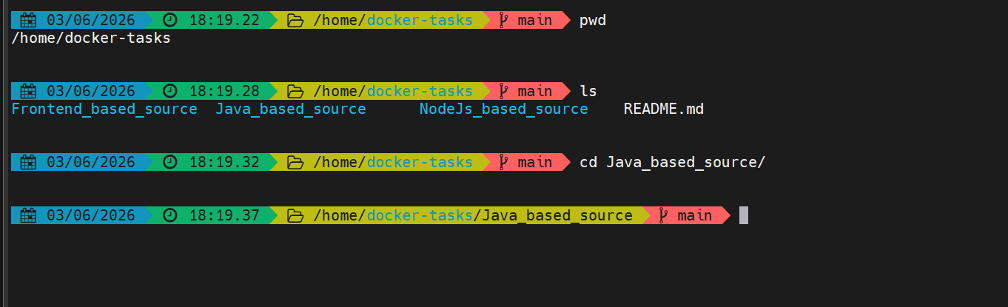

And lets create a Dockerfile
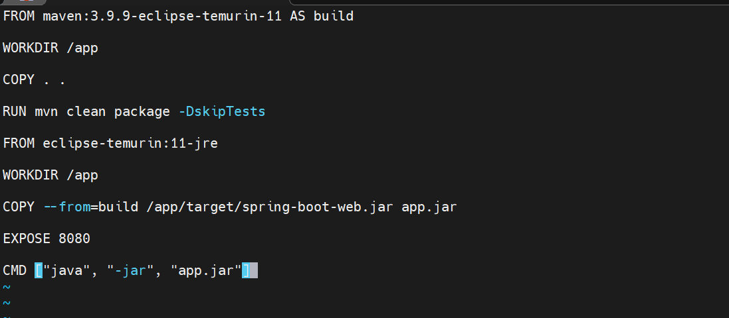

This dockerfile is a multi stage docker file which
builds the application using the docker image
That has maven and java
It creates a working directory /app
Copies everything from current directory
Builds the project and generates the artifact
At runtime it is using a smaller java image which only has java run time
It copies the jar file from build stage inside the runtime image
Exposed port 8080
And lastly it starts the application

Lets now build the image

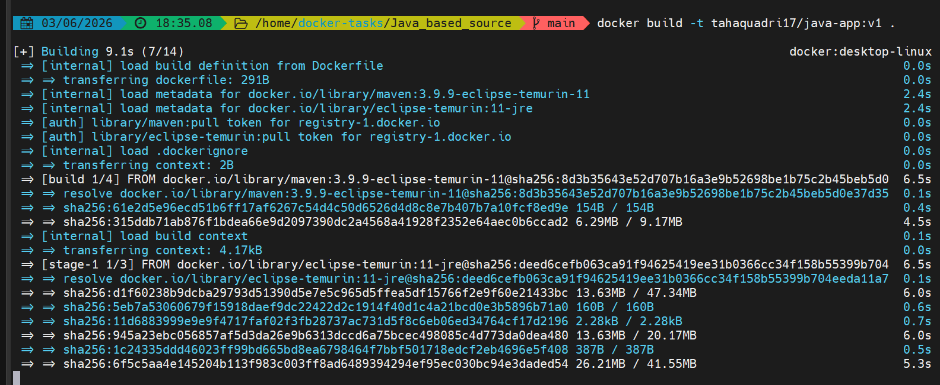

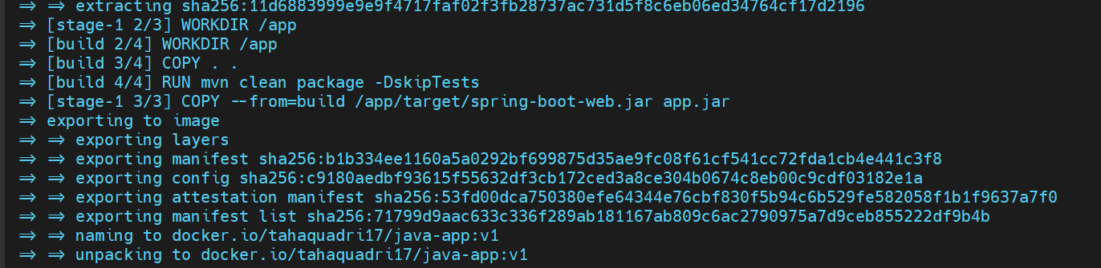

The image is built lets run the container now

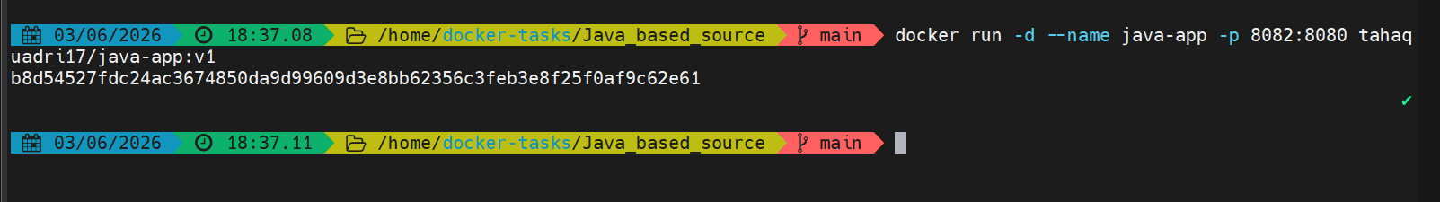

Lets check it now on the browser

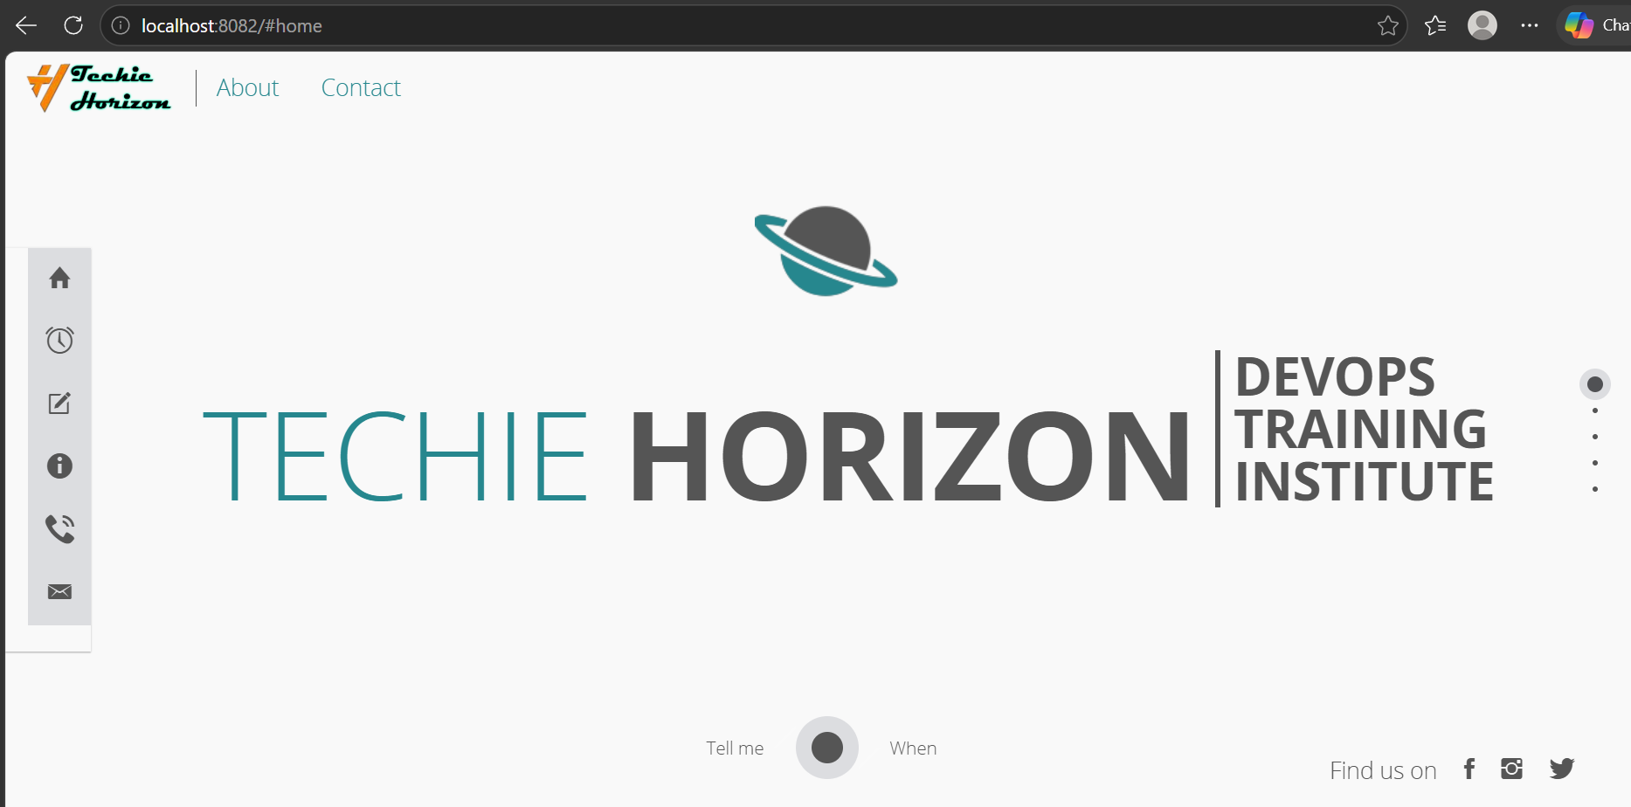

We are able to access our website using 8082 port

Lets now push the image to docker hub

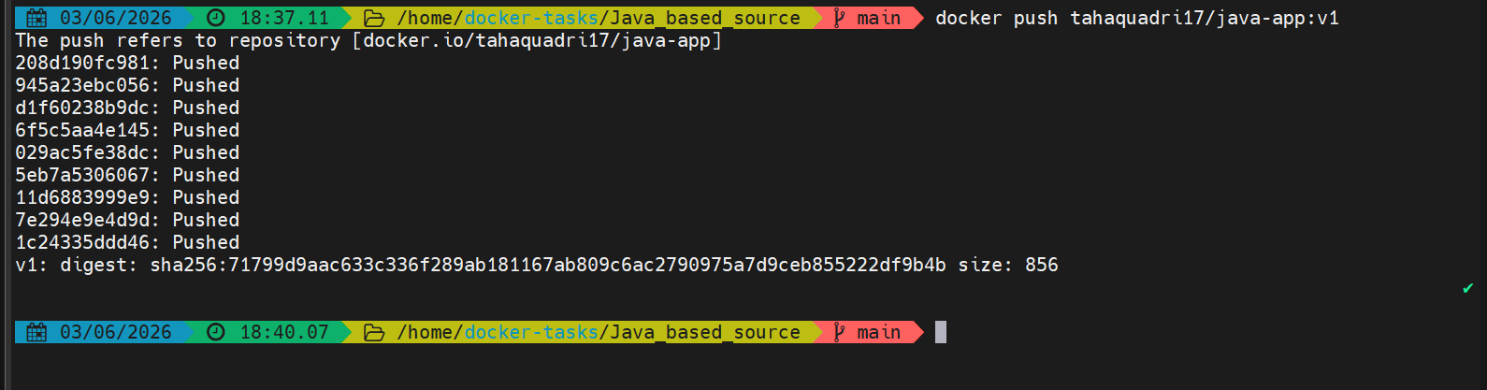

The image has been pushed
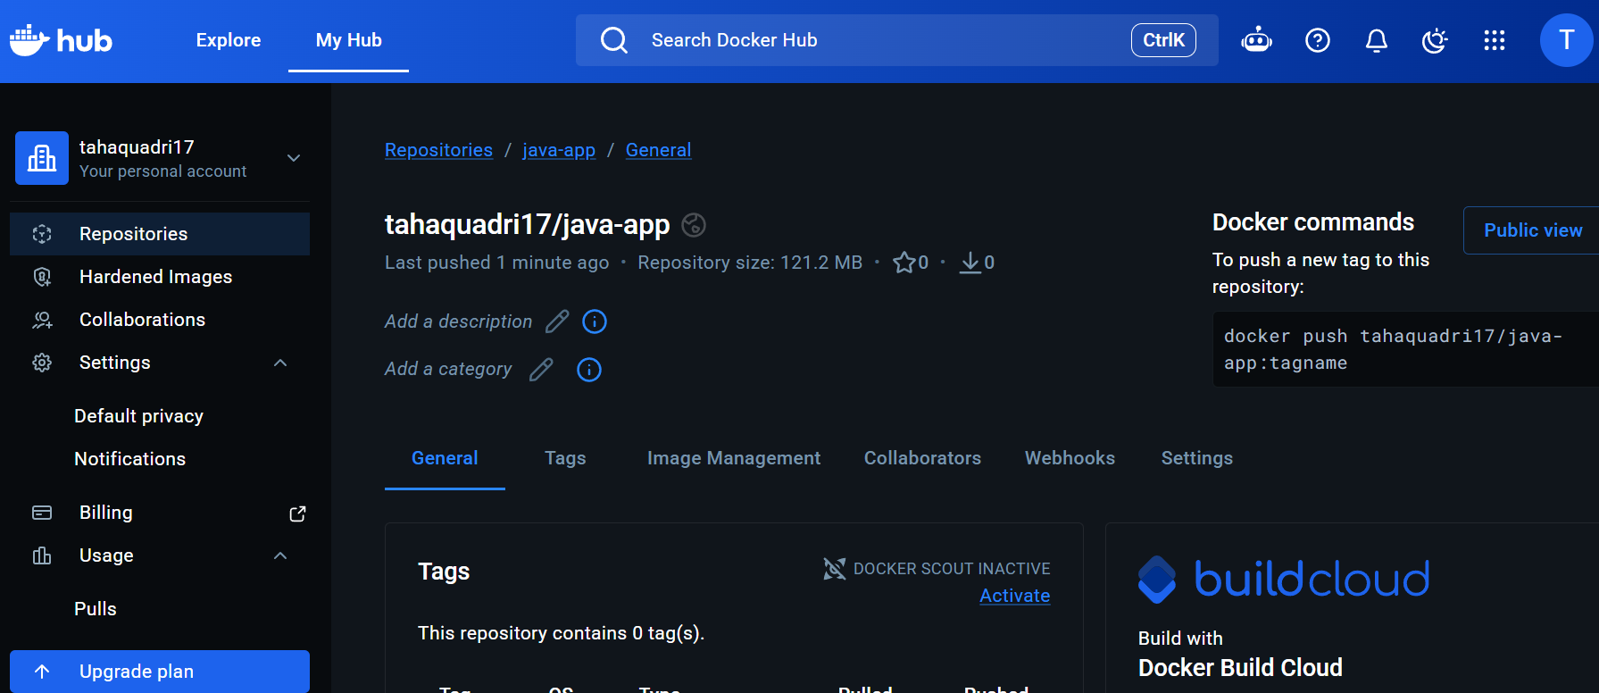

From theNode.js-based source code, write a Dockerfile, build with tagv1, run, and push it to the Docker registry.

Lets now do it for nodejs based source code

Lets go to the node js directory
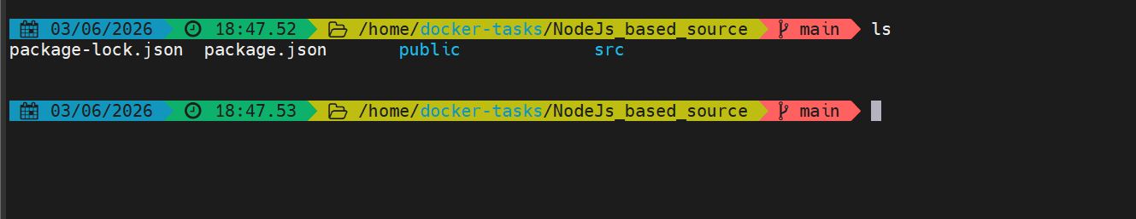

Lets now crete the dockerfile
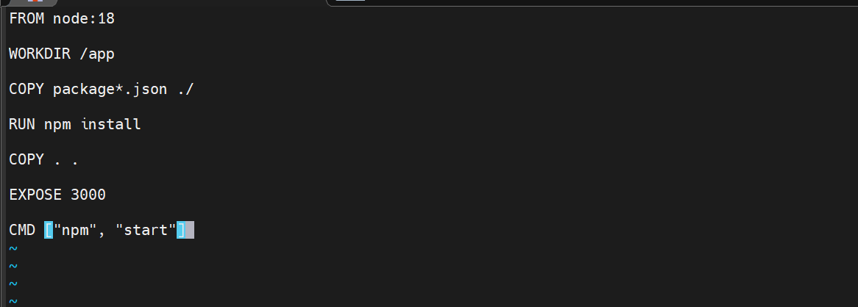

This file uses the base image node:18
Sets the work directory to /app
Copies
package.json
package-lock.json
installs the nodejs dependencies
copies the source code
exposes port 3000
starts the application

lets now build the image with tag v1

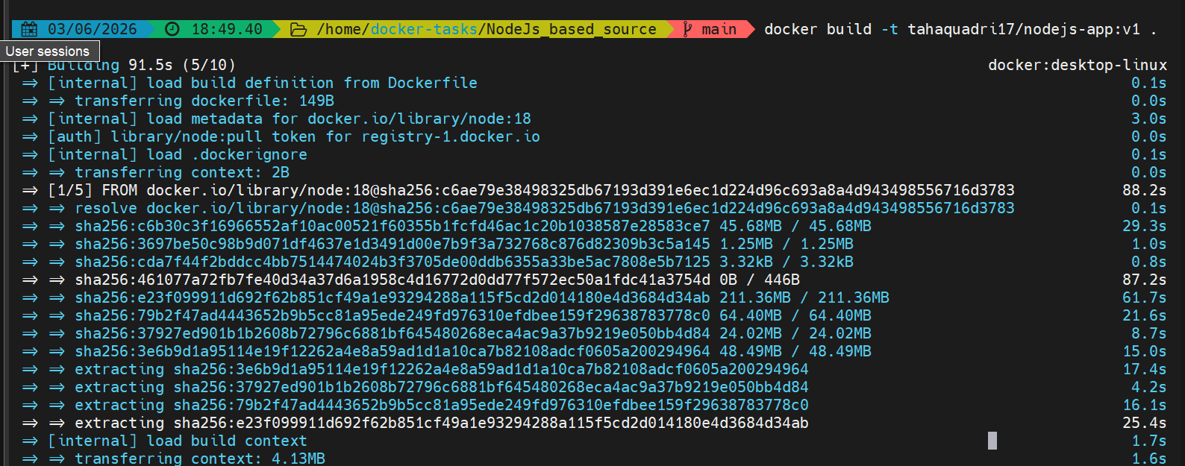

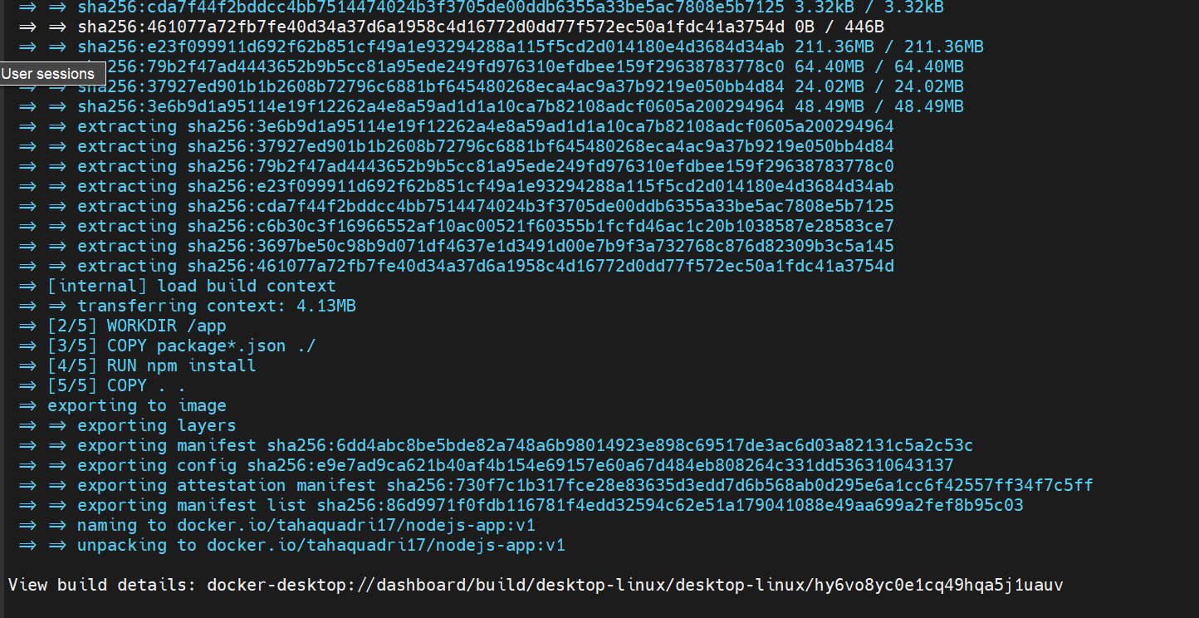

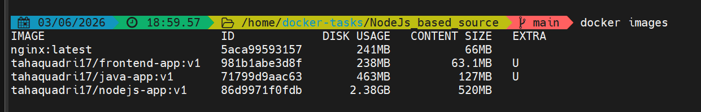

The image is created
Lets run the container on 3000

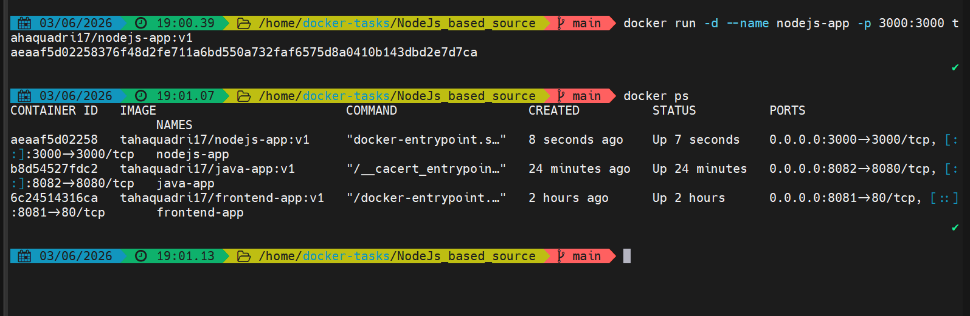

The container is running lets check it on the browser as well


It is working as well
Lets now push the image to docker hub

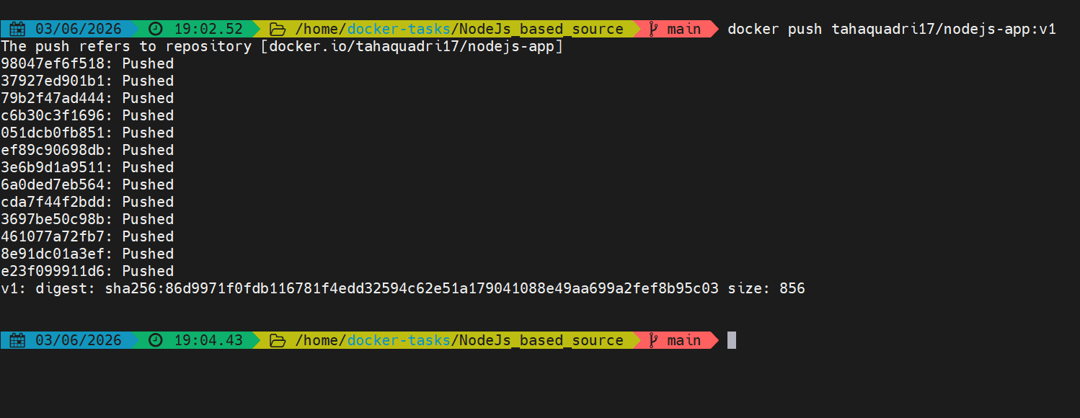

The image is pushed to dockerhub
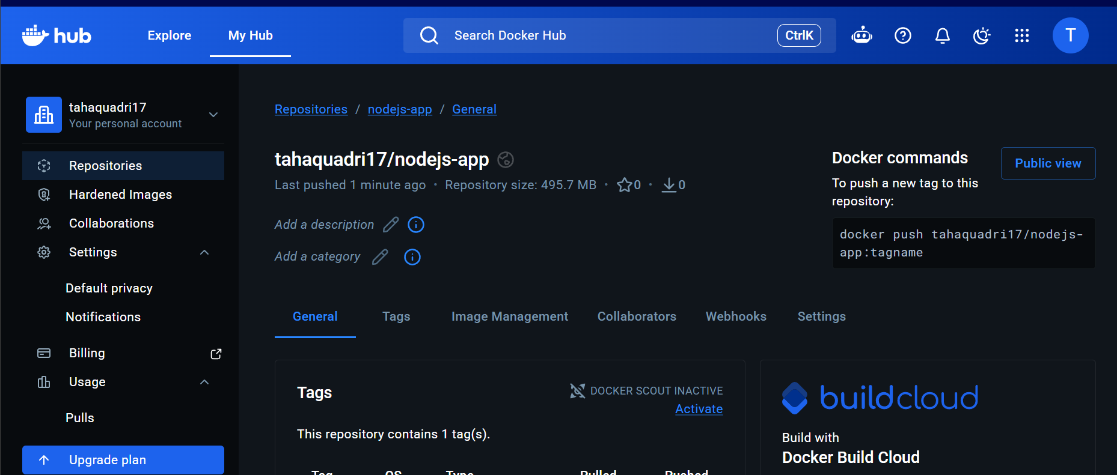

Write adocker-compose fileto set up WordPress with a MySQL database.

First install docker compose

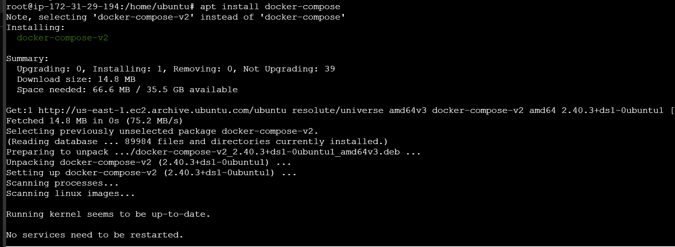

Lets create a project directory

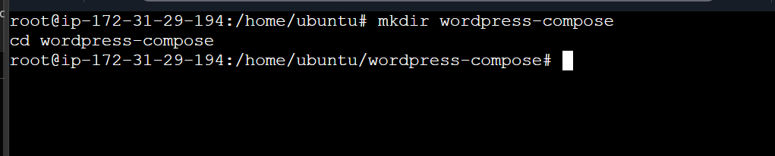

Creating a docker compose file

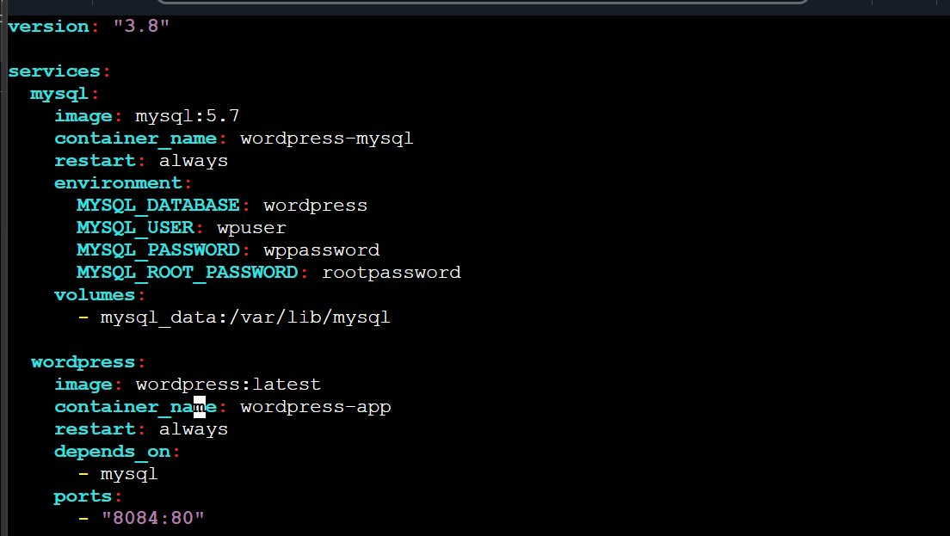

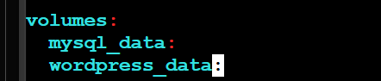

Lets run the docker compose file

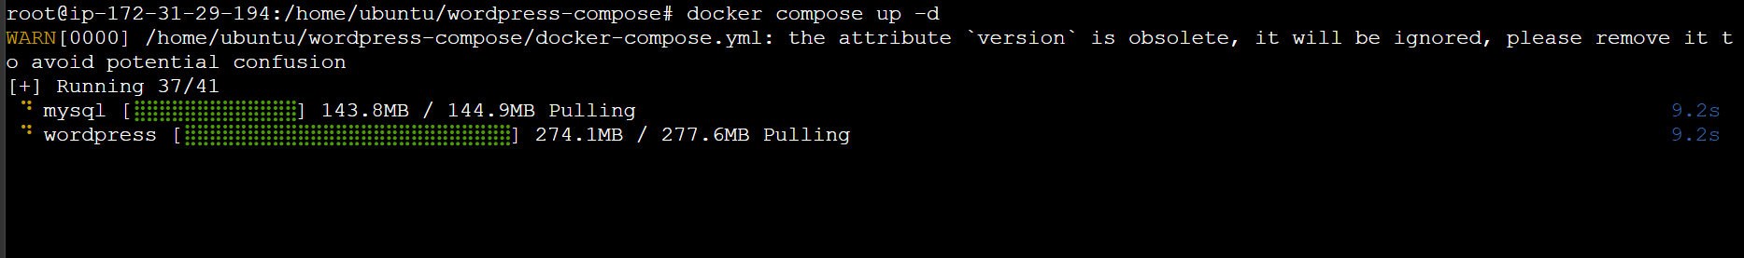

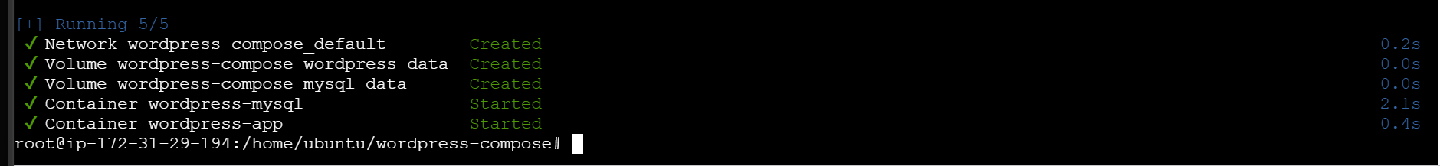

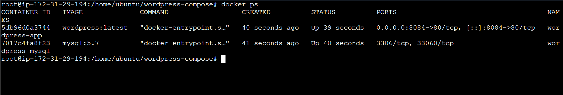
Lets check on the browser

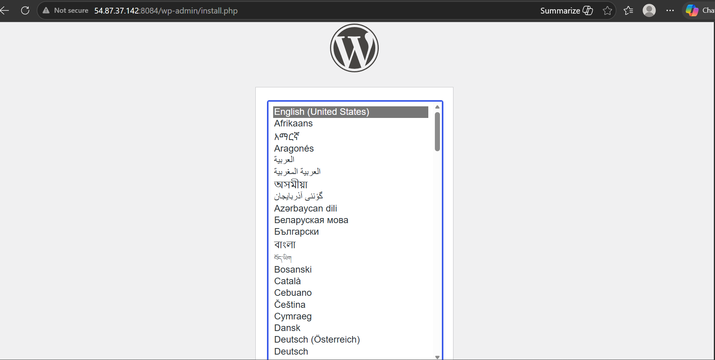
Wordpress working on 8084

